2016 Calc-assumed:
A walking club is planning a charity walk from Perth to Esperance. They plan to walk 20 km on the first day and 30 km every day after that. Food and camping supplies are to be set up at each overnight campsite in advance, using a vehicle based in Perth that is just large enough to carry enough for one campsite.

To leave the supplies at the first campsite, the vehicle must travel 40 km. For the second and third campsites, the vehicle must travel 100 km and 160 km respectively.

c) The vehicle can travel a maximum of 700 km on one tank of fuel. Determine the number of the furthest campsite the vehicle can leave supplies at, using no more than one tank of fuel.
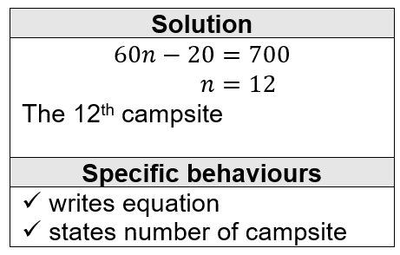

d) If fuel costs 128 cents per litre and the fuel consumption of the vehicle is 9.5 litres per 100 km, determine the total fuel cost to set up the first 20 campsites.
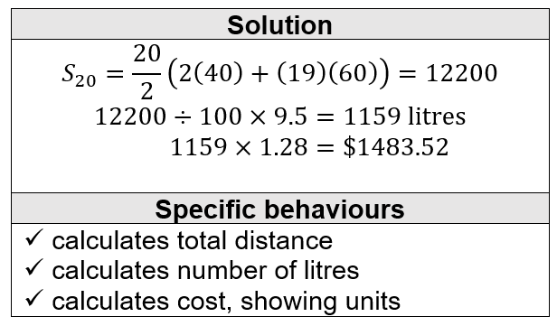

2016 Calc-assumed:
Records show that of the 1756 washing machines sold by a retailer during 2015, 464 were deluxe models and the rest were standard. Of all the machines sold, 42 were returned and 31 of these returned machines were standard models.

Determine how many of the standard models were not returned.
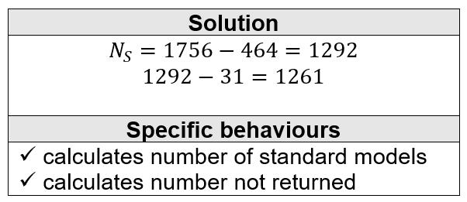

Is there any indication that the likelihood of a machine being returned is independent of the model type? Explain your answer.
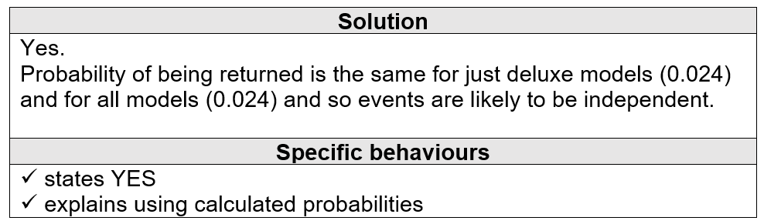

2016 Calc-assumed:
The graph of two functions and a circle of radius 3 units are shown.

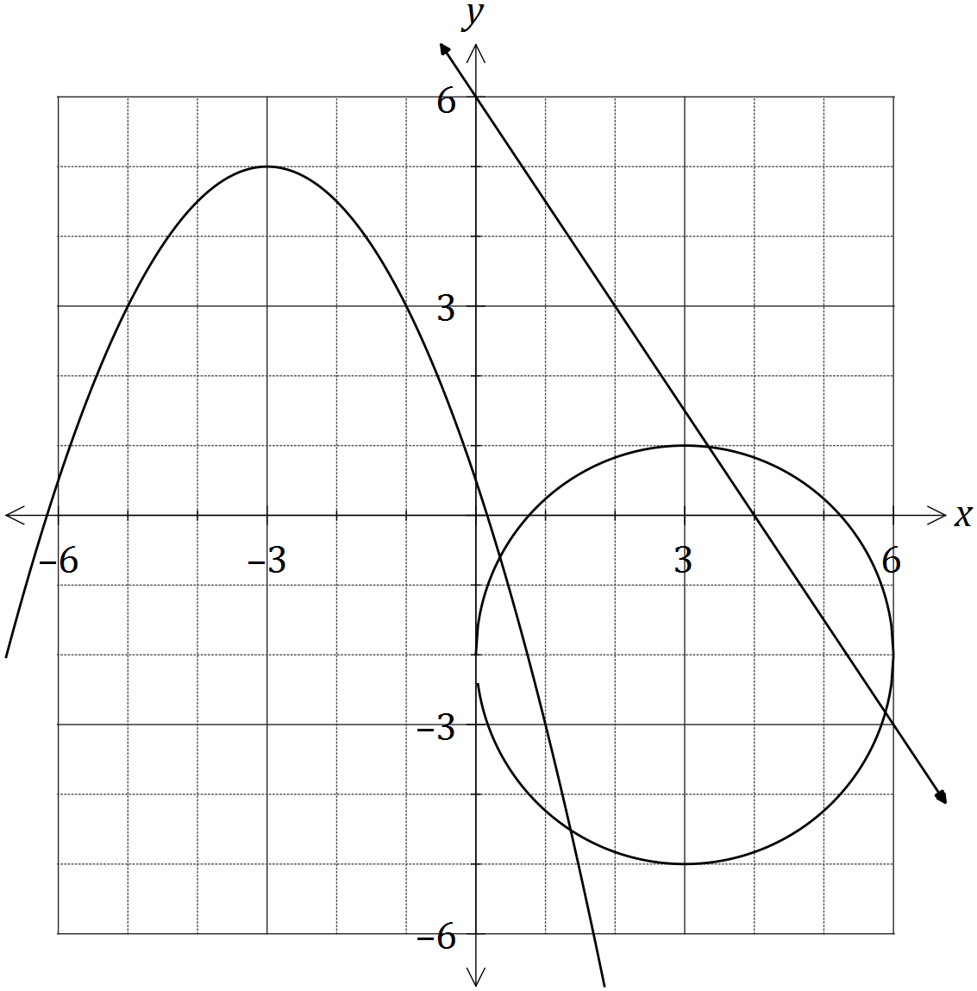
The other function is $g\left(x\right)=cx^{2}+dx+e$.
State the range of the function $y=-g(x)$.
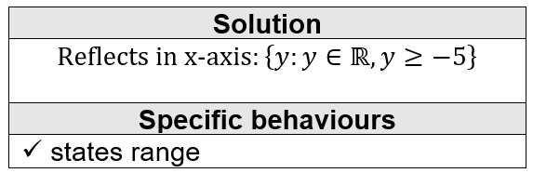

2016 Calc-assumed:
The imprisonment rate $R$, in number of prisoners per 100 000 people, in the US between the years 1960 and 2000, can be modelled by the following equation, where $n$ is the year.

$$R=85{\left(1.038\right)}^{n-1960}$$

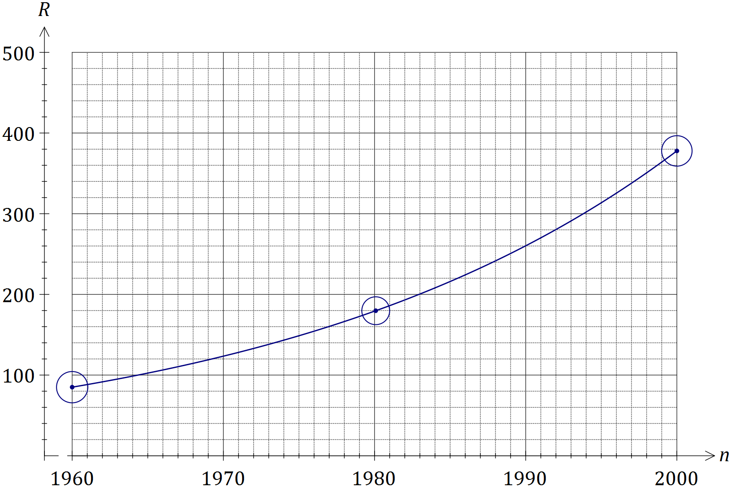

a) The population of the US was 266 million in 1995. Determine the number of prisoners in the US at this time, to the nearest 1 000.
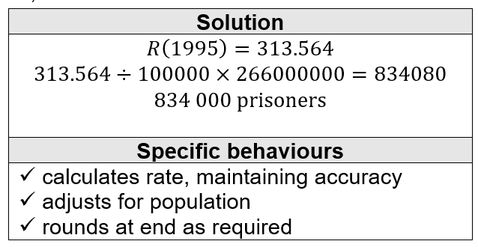
b) When $R$ first exceeded 500, steps were taken to address the exponential growth in the prison population and the model no longer applied. In what year did this occur.
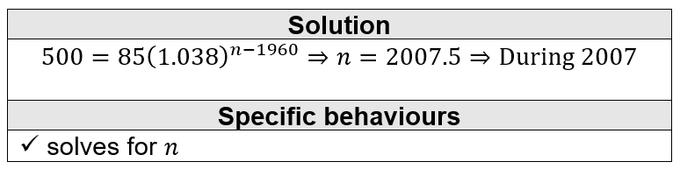

2016 Calc-assumed:
A sequence is defined by $T_{n+1}=T_{n}-7, T_{1}=111$.
Determine the value of $n$ that maximises $S_{n}$.
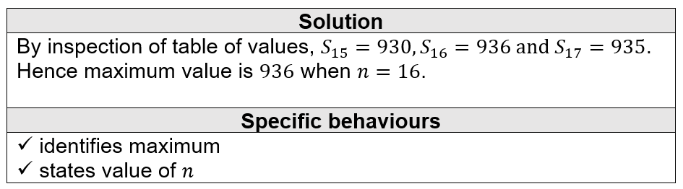

2017 Calc-assumed:
The number of followers of a social media influencer, counted at the start of five successive months, is shown in the exponential graph below.

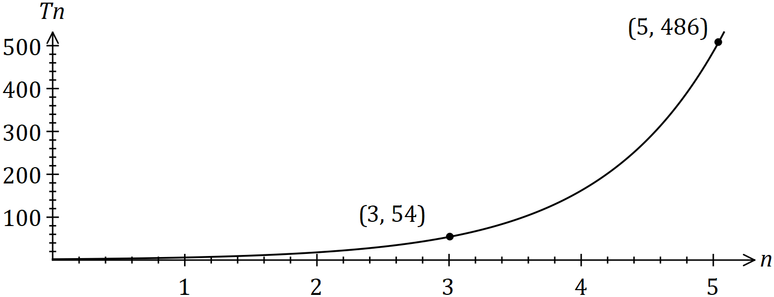

The number of followers ($T_{n}$) at the start of month $n$ can be modelled by the recursive equation $T_{n+1}=rT_{n} , T_{1}=a$.
When the number of followers reached 2 million, the influencer fell out of favour and started to lose 40% of their followers each month. After how many months from this time will they have less than 1 000 followers.
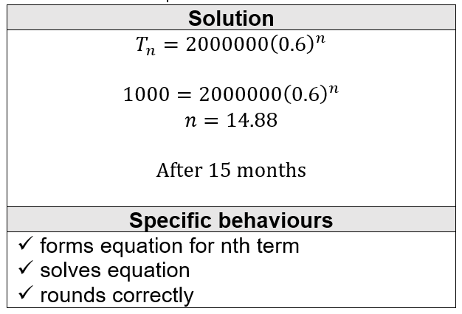

2017 Calc-assumed:
A particle is moving along a straight line so that its displacement, $x$ metres, from a fixed point $O$ after $t$ seconds is given by
$$x=5-\frac{18t}{5}+\frac{12t^{2}}{5}-\frac{2t^{3}}{5} .$$
Sketch the displacement of the particle on the axes below for $0≤t≤5$.
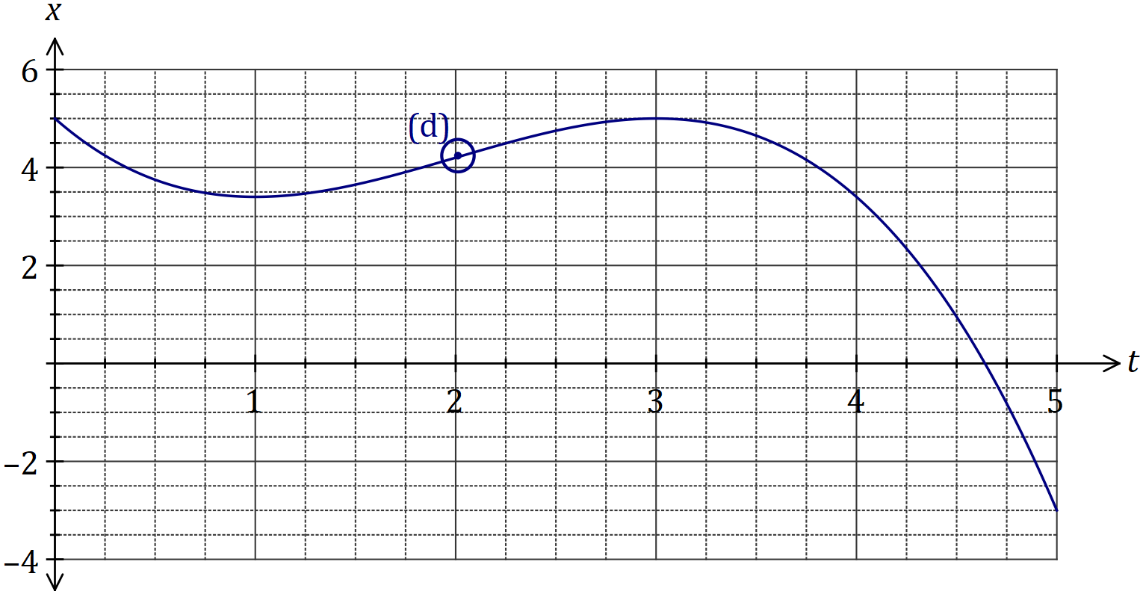
a) Determine the velocity of the particle when $t=0.5$.
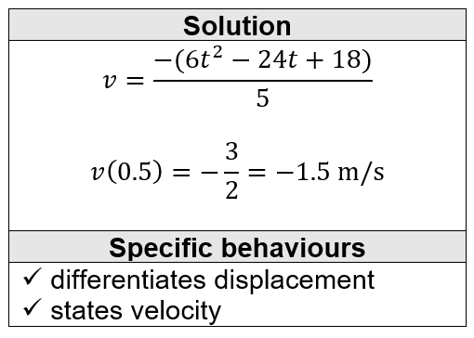
b) For how long during the first five seconds is the particle is moving towards $O$.
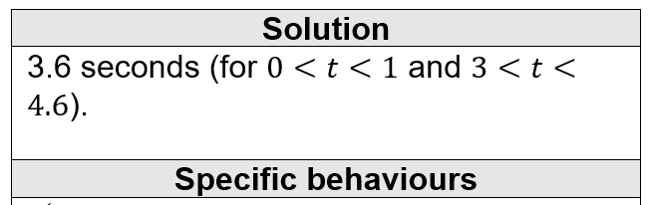
c) Circle the point on the graph where the particle is moving with the maximum velocity and explain what feature of the graph you used to choose this point.
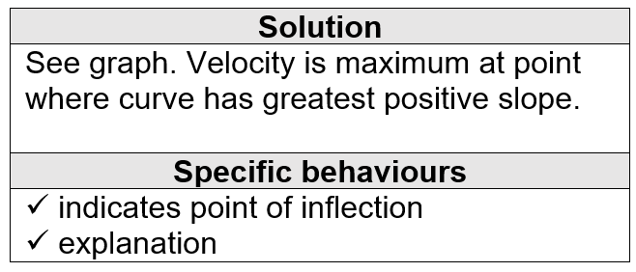

2017 Calc-assumed:
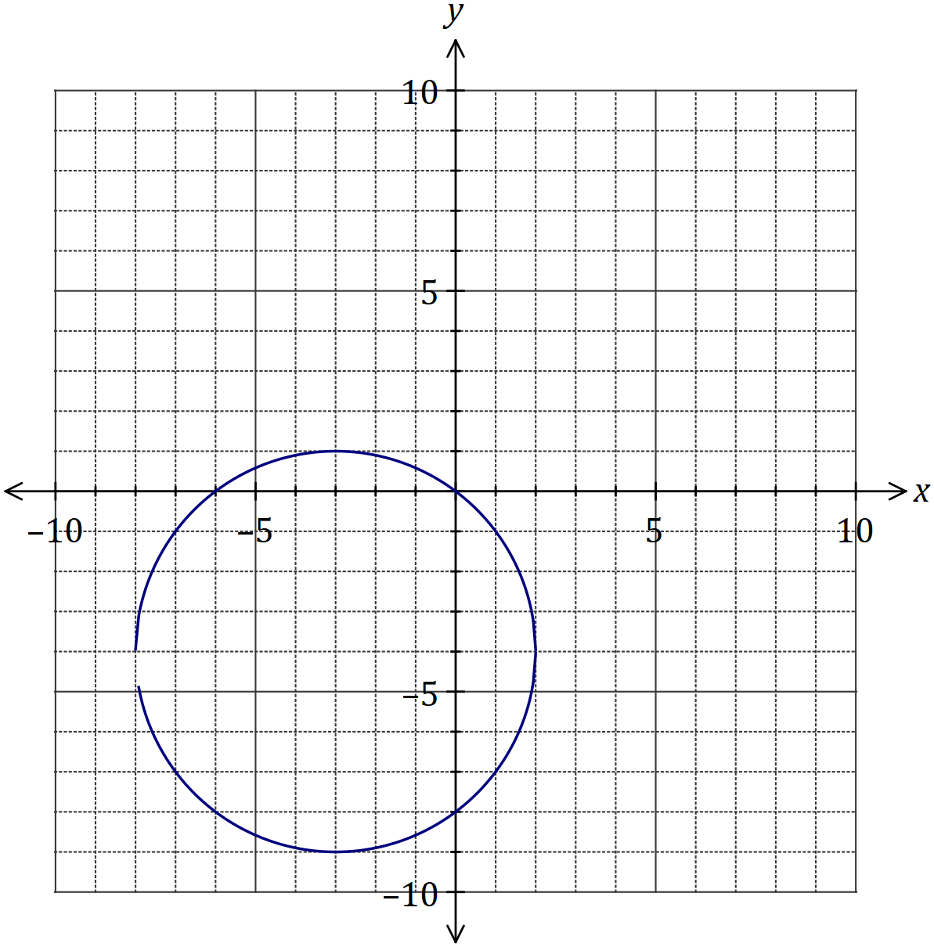
How does the vertical line test indicate that $y$ is not a function of $x$?
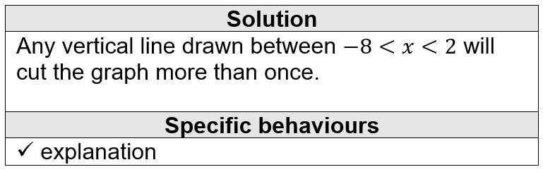
2017 Calc-assumed:
Events $A$ and $B$ occur at random and it is known that $P\left(B\right)=0.6$ and $P\left(A∪B\right)=0.72$.
a) Determine $P(A)$ when $A$ and $B$ are independent.
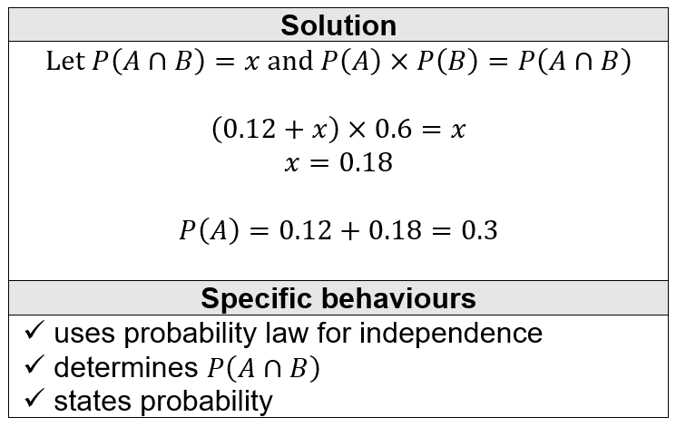

b) Determine $P\left(B|A\right)$ if $P\left(B|\overline{A}\right)=0.65$.
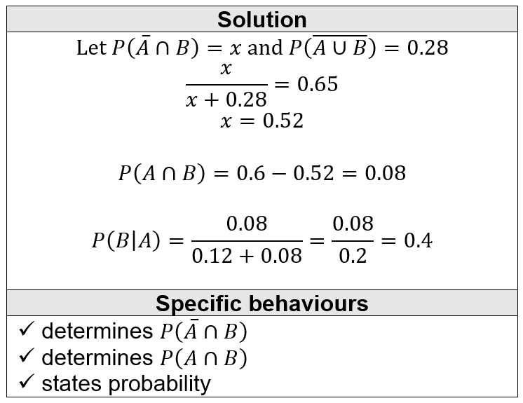

2018 Calc-free:
Let $f\left(x\right)=\begin{matrix}x \\ \overline{x+3}\end{matrix}$. The graph of $y=f(x)$ is shown below.
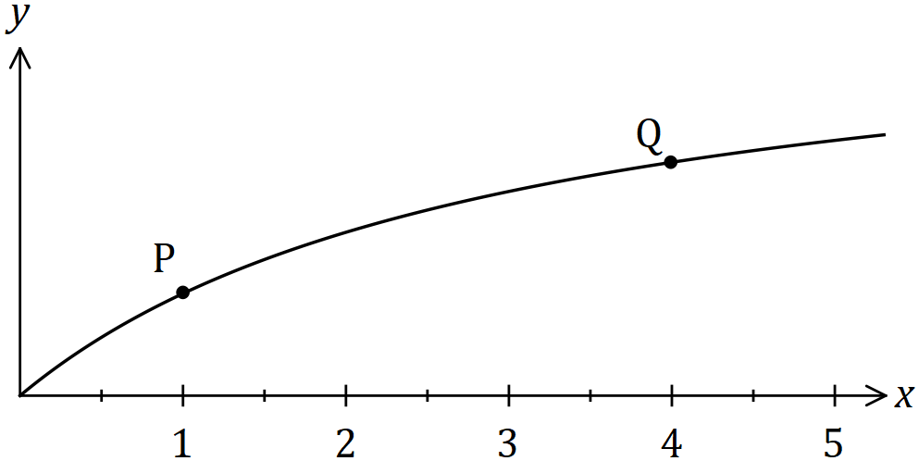
Use the formula $f^{'}\left(x\right)=\lim_{h→0}{\begin{matrix}f\left(x+h\right)-f(x) \\ \overline{ h }\end{matrix}}$ to determine the gradient of the curve at $P$.
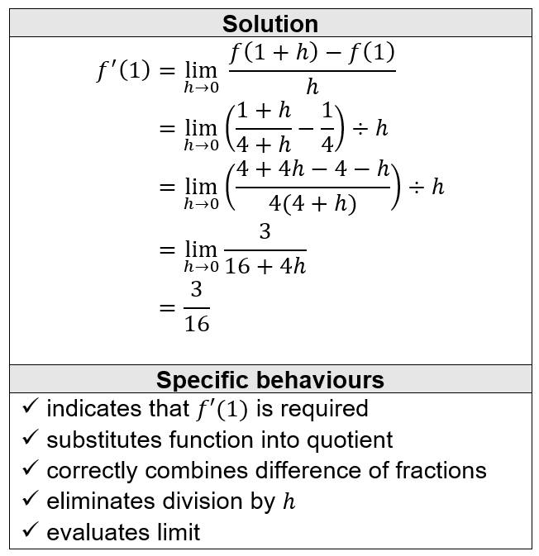

2017 Calc-free:
The graph of $y=f(x)$ is shown below, where $f\left(x\right)=\sqrt{2x+1}$.
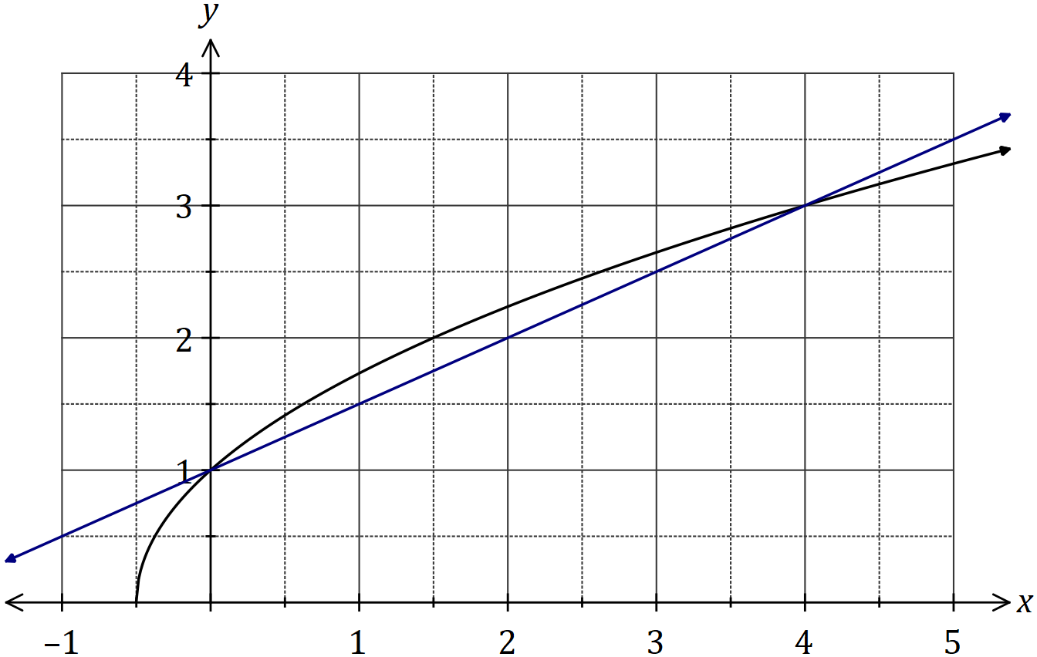
The difference quotient is shown here:
$$\frac{f\left(x+h\right)-f(x)}{h}$$

Evaluate the difference quotient as $h→0$ to determine the slope of $f(x)$ when $x=0$.
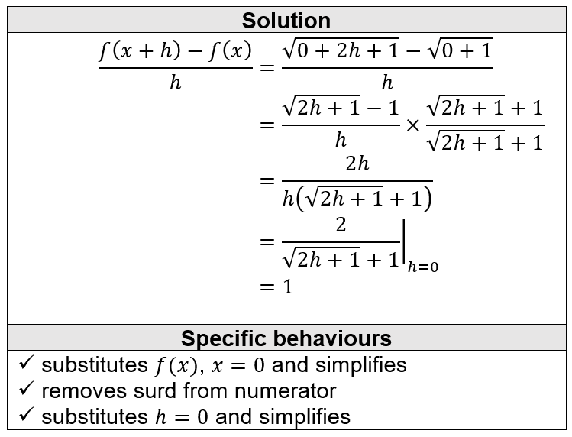

2016 Calc-free:
The first three terms, in order, of geometric sequence are $x-5$, $x-1$ and $2x+4$.
Determine all possible values for the fourth term of the sequence.
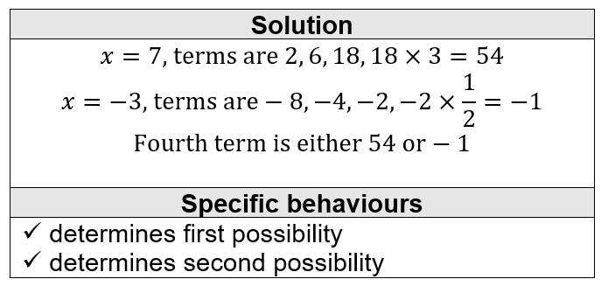

2017 Calc-assumed:
The number of followers of a social media influencer, counted at the start of five successive months, is shown in the exponential graph below.



The number of followers ($T_{n}$) at the start of month $n$ can be modelled by the recursive equation $T_{n+1}=rT_{n} , T_{1}=a$.
When the number of followers reached 2 million, the influencer fell out of favour and started to lose 40% of their followers each month. After how many months from this time will they have less than 1 000 followers?


Let $f\left(x\right)=\begin{matrix}x \\ \overline{x+3}\end{matrix}$. The graph of $y=f(x)$ is shown below.

Use the formula $f^{'}\left(x\right)=\lim_{h→0}{\begin{matrix}f\left(x+h\right)-f(x) \\ \overline{ h }\end{matrix}}$ to determine the gradient of the curve at $P$.
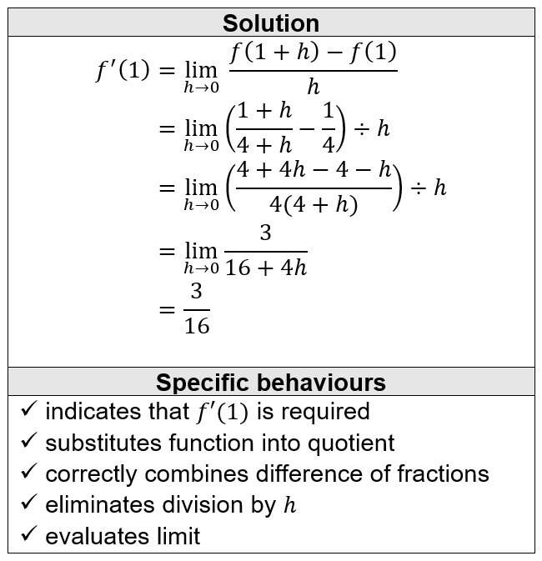
2018 Calc-assumed:
The temperature $T$ of a cast taken out of an oven cools according to the model $T=840{\left(0.94\right)}^{t}$, where $t$ is the time in minutes since the cast was removed from the oven. $T$ is measured in $°C$.
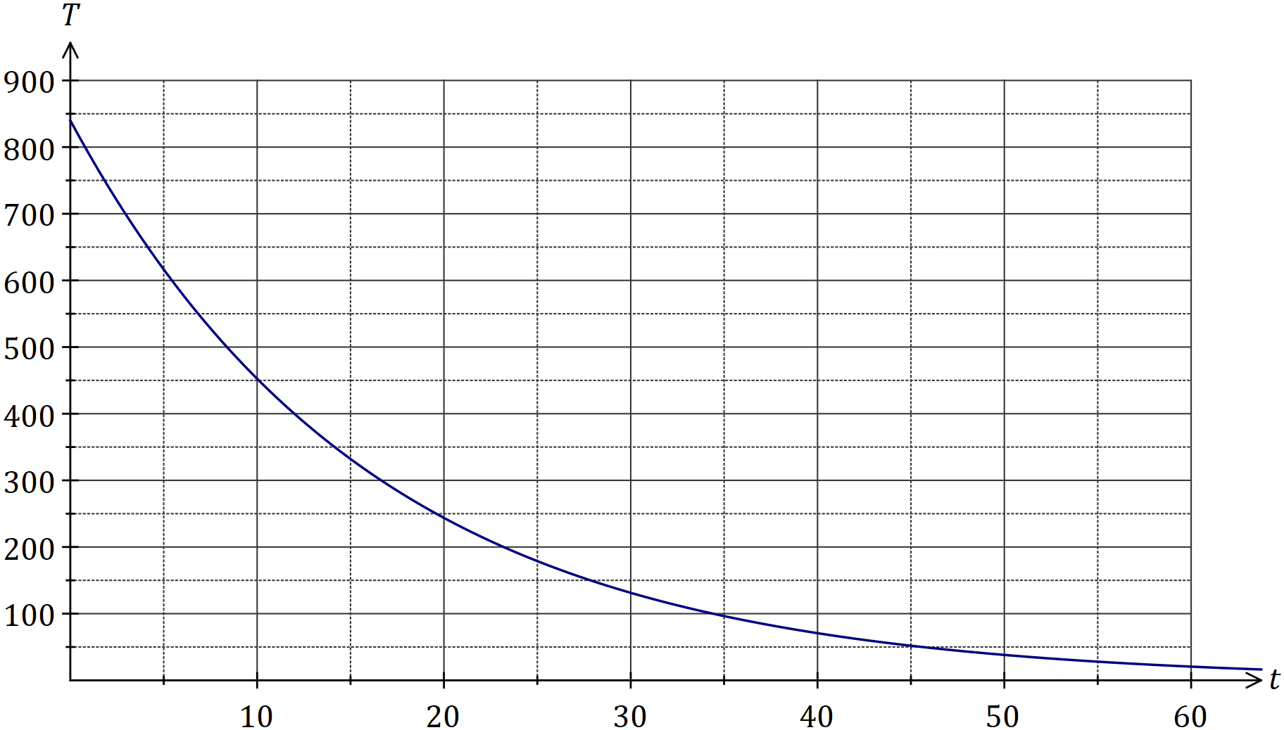
The temperature of the cast falls to room temperature of$15°C$.
a) Determine the time taken for the cast to reach room temperature.
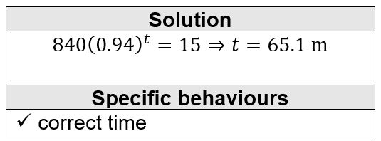
b) Comment on the usefulness of the model for large values of $t$.
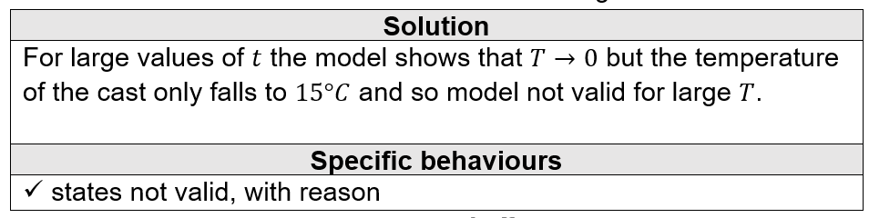

The graph of $y=\sin{x}$ is shown below. On the same axes, sketch $y=\sin{2x}$.
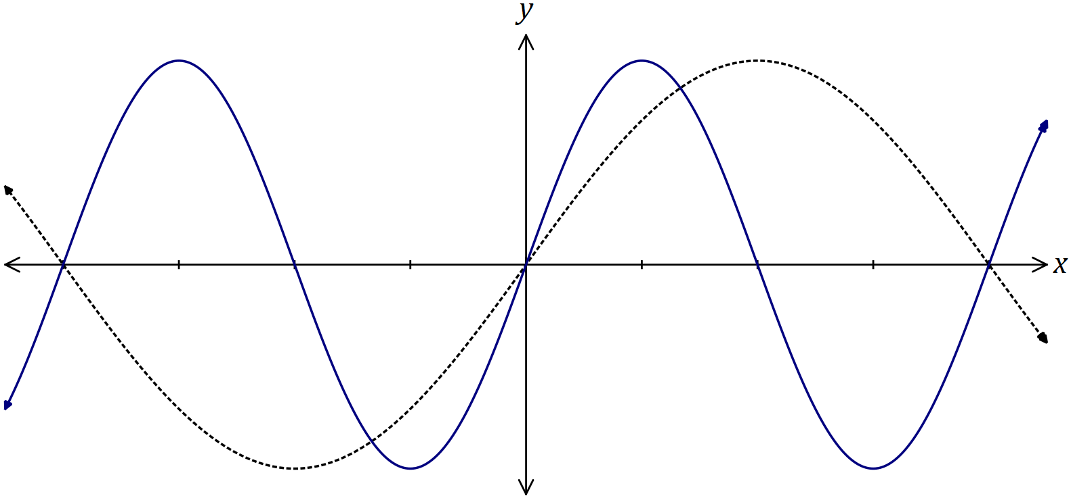

2018 Calc-assumed:
Two water containers, initially empty, are being filled with water. The amount of water added to container $A$ each minute follows an arithmetic sequence, with $3$ mL poured in during the first minute and $6$ mL poured in during the second minute. The amount of water added to container $B$ each minute follows a geometric sequence, with $2$ mL poured in during the first minute and $2.2$ mL poured in during the second minute.
Container $B$ first holds more water than container $A$ at the end of minute $m$.
a) Determine the value of $m$.
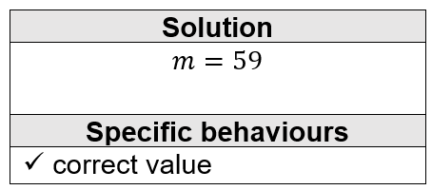

b) State, to the nearest mL, how much more water $B$ contains than $A$ at this time.
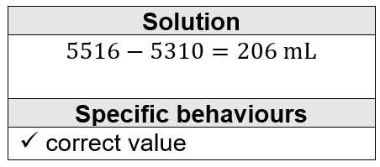

2018 Calc-assumed:
A diagnostic test for a disease has a $97\%$ chance of giving the correct outcome and it is known that $0.5\%$ of all sheep on a station have the disease. It can be assumed that the correct outcome of the test is independent of whether a sheep has the disease.
a) A sheep is randomly selected for the test from those on the station. Determine the probability that:
i) the sheep has the disease, but the test indicates that it does not.
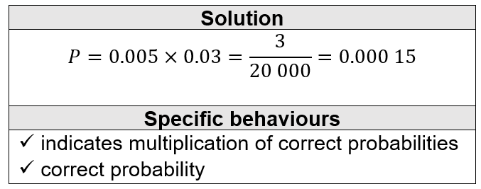
ii) the sheep actually has the disease if the test indicates that it does.
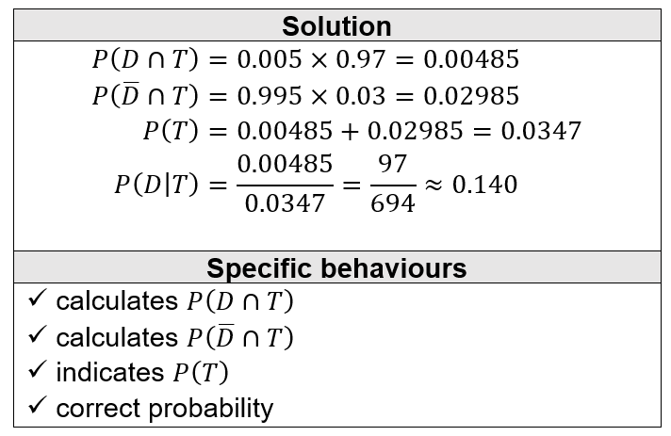

b) Two sheep are randomly selected for the test from those on the station. Determine the probability that just one of the sheep is diagnosed correctly.
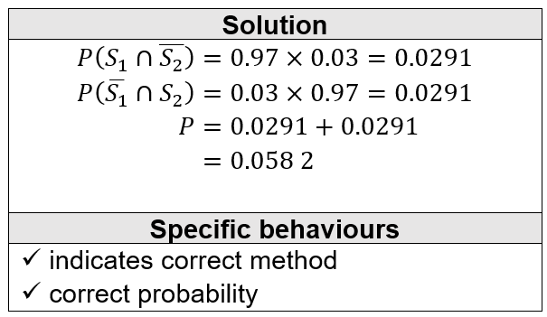

2019 Calc-assumed:
A drone is flying in a straight line and at a constant height $h$ m above a level pitch towards a thin goal post. It maintains a constant speed of $4.5$ ms⁻¹.
Initially, the angle of depression from the drone to the base of the post is $8°$. Exactly $3$ seconds later this angle has increased to $10°$.
a) Sketch a diagram to show the two angles of depression from the drone to the base of the post.
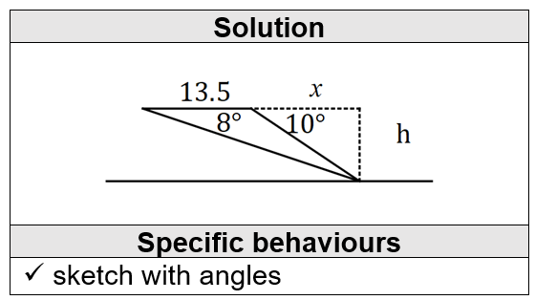

b) Determine, showing all working, the value of $h$ and calculate the time after leaving its initial position that the drone will collide with the post.
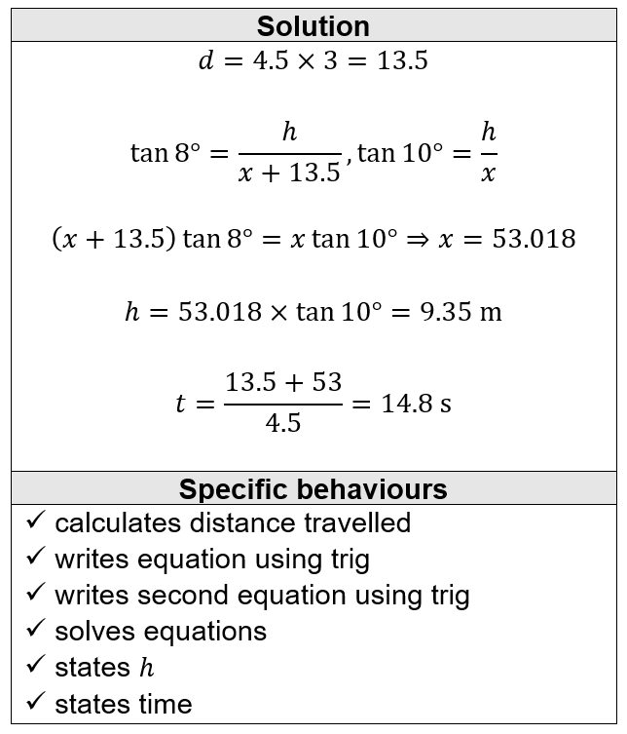

2019 Calc-assumed:
A geometric sequence has a second term of $-2.5$ and a sum to infinity of $8$.
Determine the sum of the first $3$ terms of the sequence.
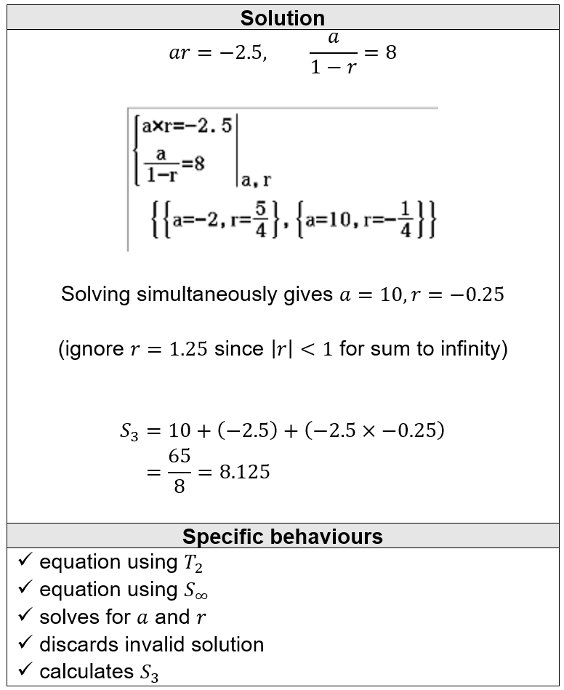

2019 Calc-assumed:
The function $f$ is defined by $f(x)=x^{3}-2x^{2}-4x+8$, where $a, b$ and $c$ are constants.

The graph of $y=f(x)$ has the following features:
- Passes through $(0, 8)$ and $(-2, 0)$
- Has a local minimum at $(2, 0)$
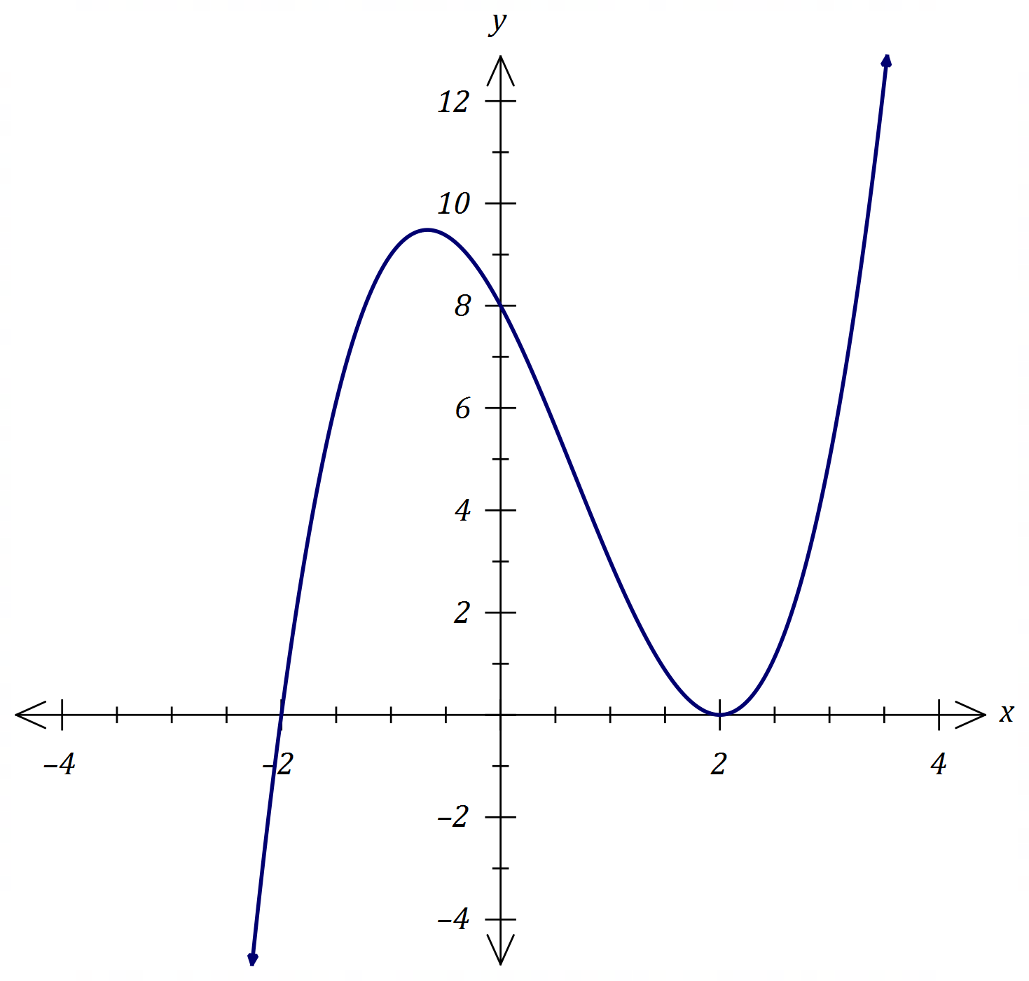
Determine the coordinates of the point where the tangent to $y=f(x)$ at $(0, 8)$ intersects the curve $y=f(x)$, other than at the point of tangency.
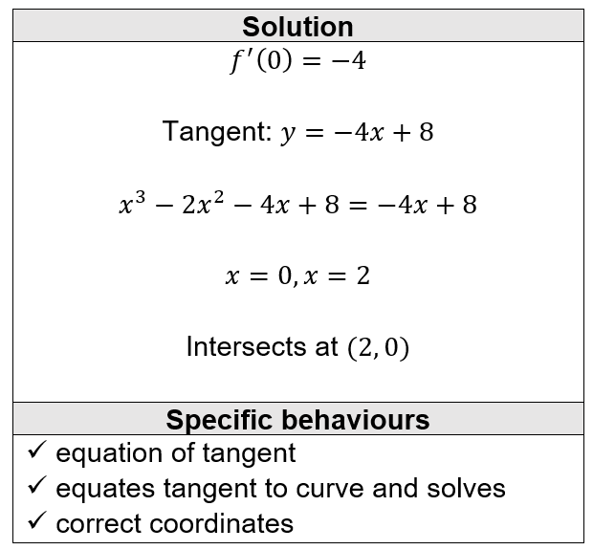

2019 Calc-assumed:
When a patient takes a painkilling drug $A$, the probability that they experience some side effects is known to be $0.1$.
a) A doctor prescribes drug $A$ to two unrelated patients. Determine the probability that:
i) neither patient experiences some side effects.
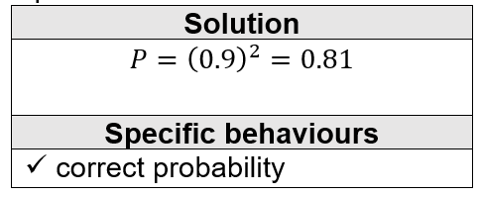
ii) one patient experiences some side effects and the other does not.
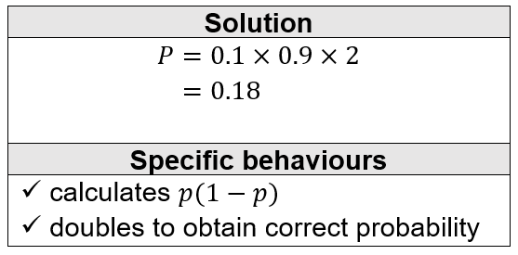
Other painkilling drugs are available. Of those who take drug $A$, $88\%$ of patients who suffer some side effects will switch to another drug whereas no patient who has no side effects will switch.
b) The doctor prescribes drug $A$ to a patient. Determine the probability that the patient does not switch to another drug.
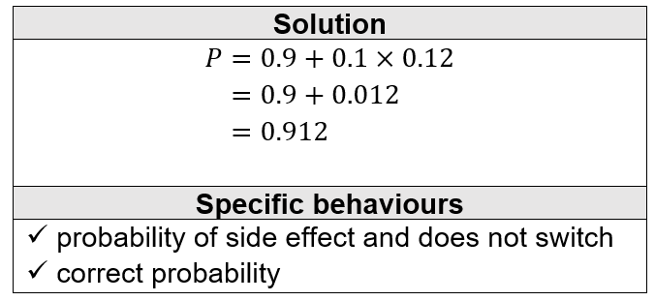
c) The doctor prescribes drug $A$ to three unrelated patients. Determine the probability that at least one of these patients switch to another drug.
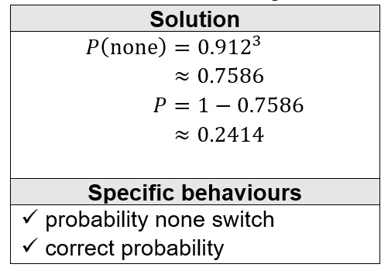

2019 Calc-assumed:
A fair six-sided dice numbered $1, 2, 3, 4, 5$ and $6$ is thrown $n$ times until it lands on a $6$.
a) Determine the probability that the first $6$ is thrown in $12$ or less attempts
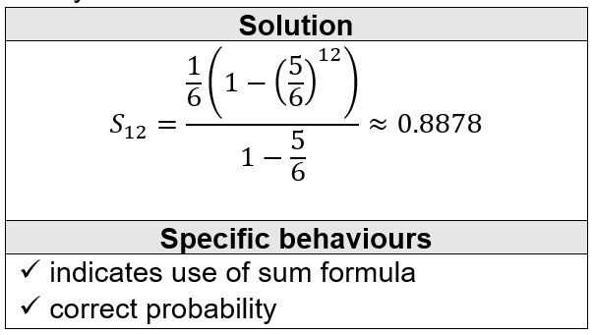
b) The probability that the first $6$ is thrown in $k$ or less attempts must be at least $99\%$. Determine the least value of integer k.
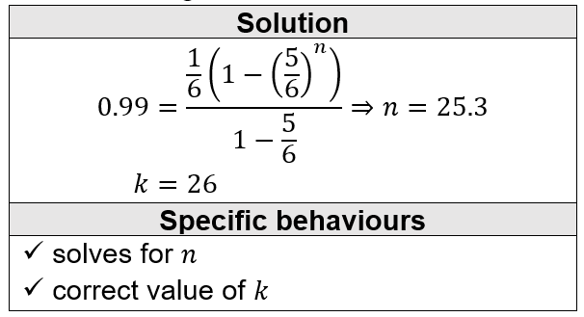

2019 Calc-free:
Solve the following equations:
a) $\tan{(2x)}=\sqrt{3}$, $0≤x≤π$.
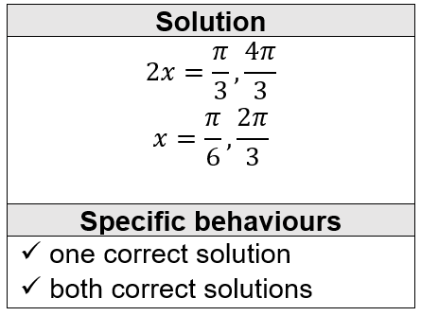

b) $2\cos{(x-60°)}=\sqrt{3}+\cos{x}$, $0°≤x≤360°$.
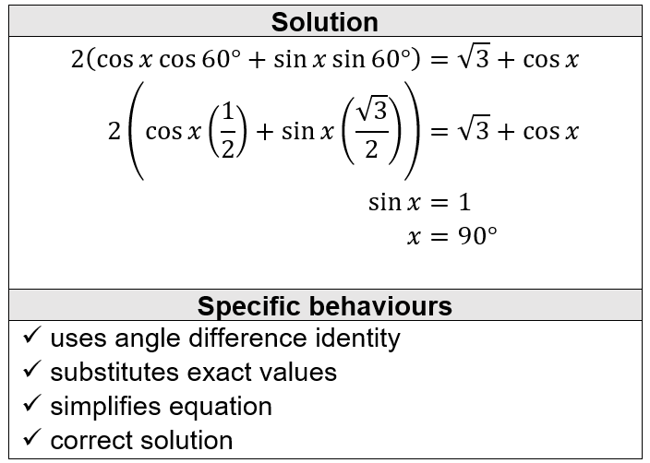

2019 Calc-free:
The graph of $y=\sin{(ax+b)}$ is shown below, where $a$ and $b$ are positive constants.
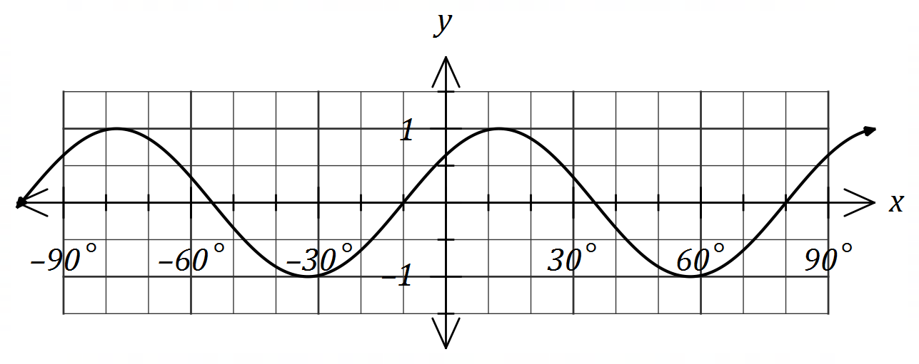
Determine the minimum possible value of each of the constants.
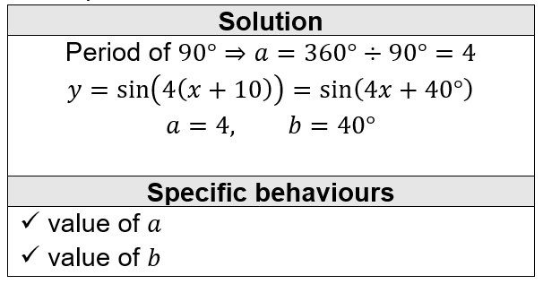

2019 Calc-free:
Determine the coordinates of all stationary points of the curve $y=x^{4}+2x^{2}-8x+9$.
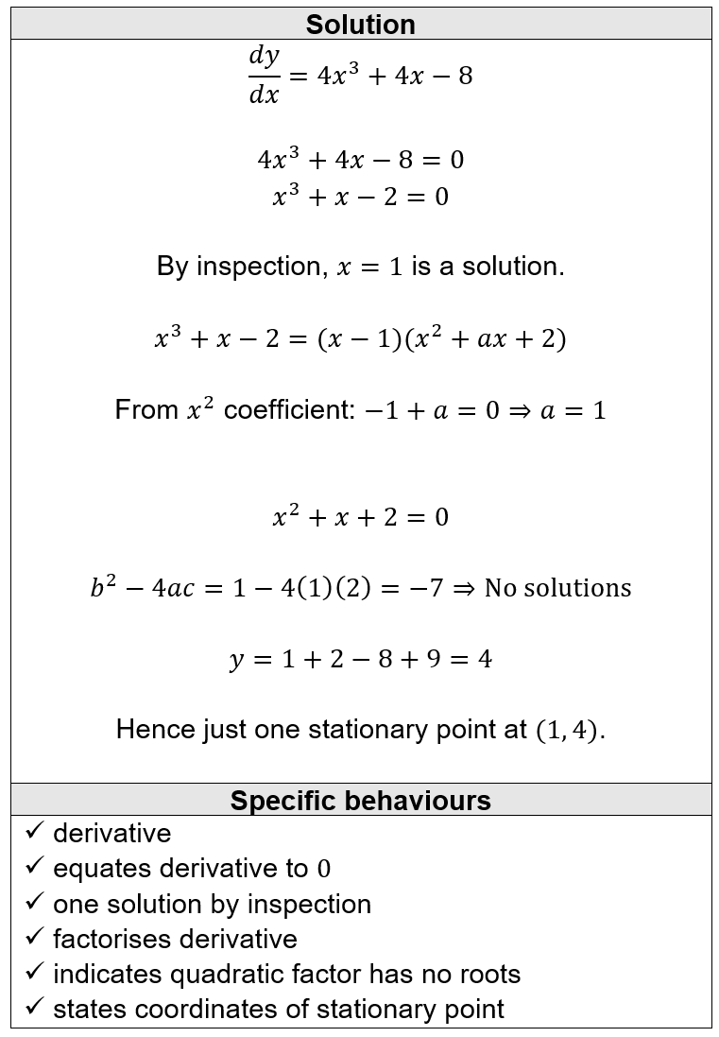

2015 A Calc-free:
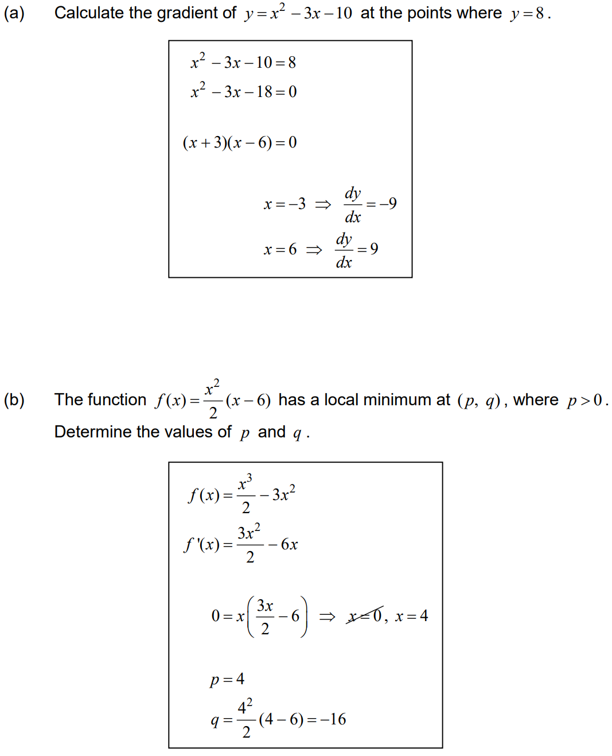

2015 A Calc-assumed:
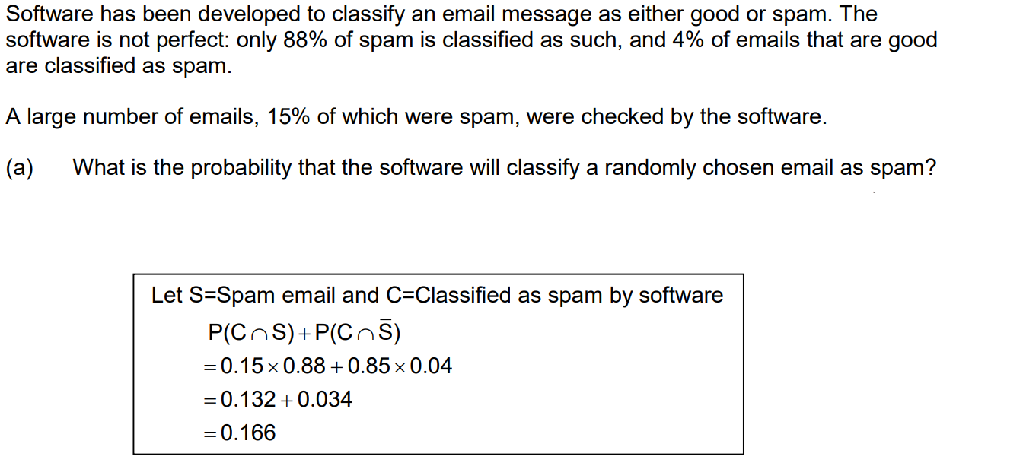
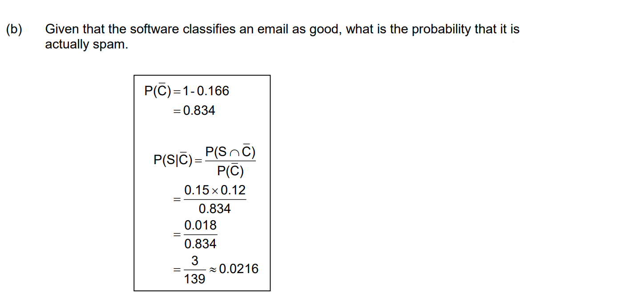

2015 A Calc-assumed:
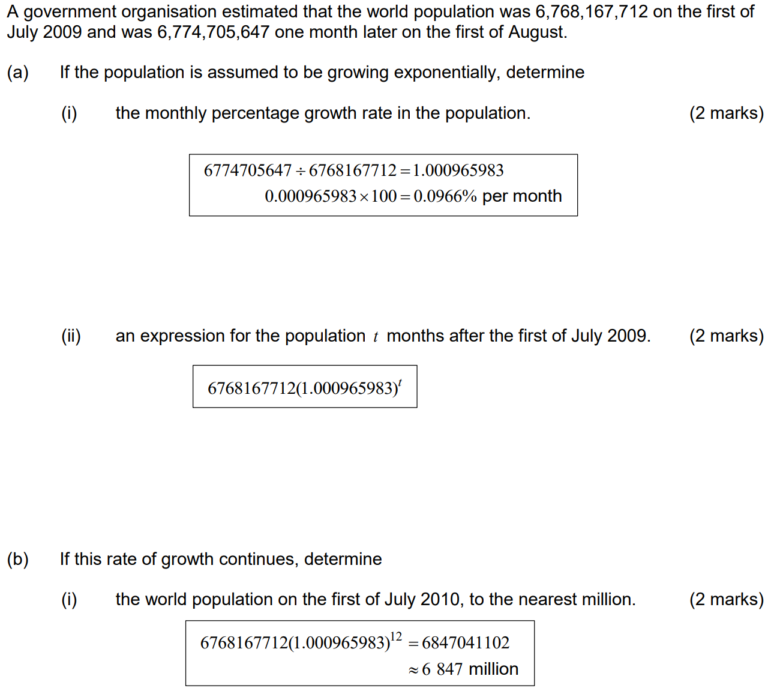

2015 A Calc-assumed:
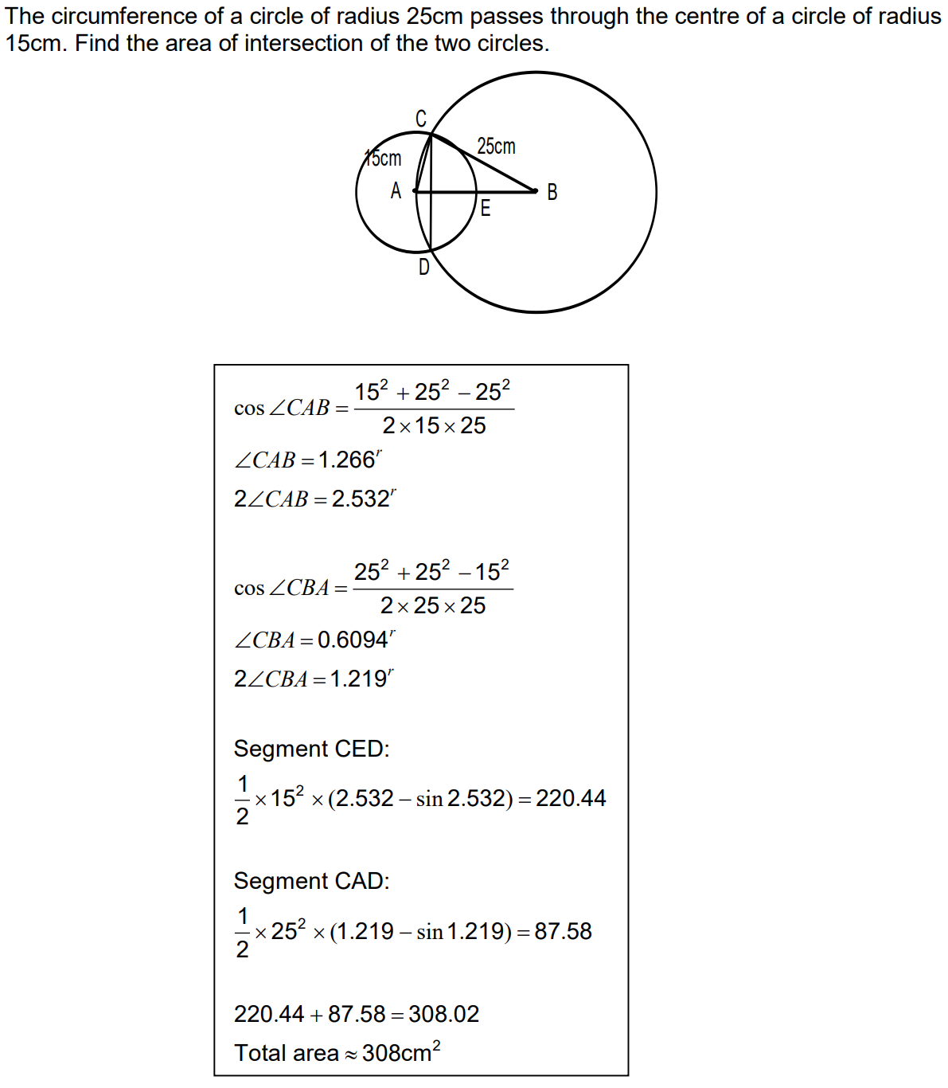

2015 B Calc-free:
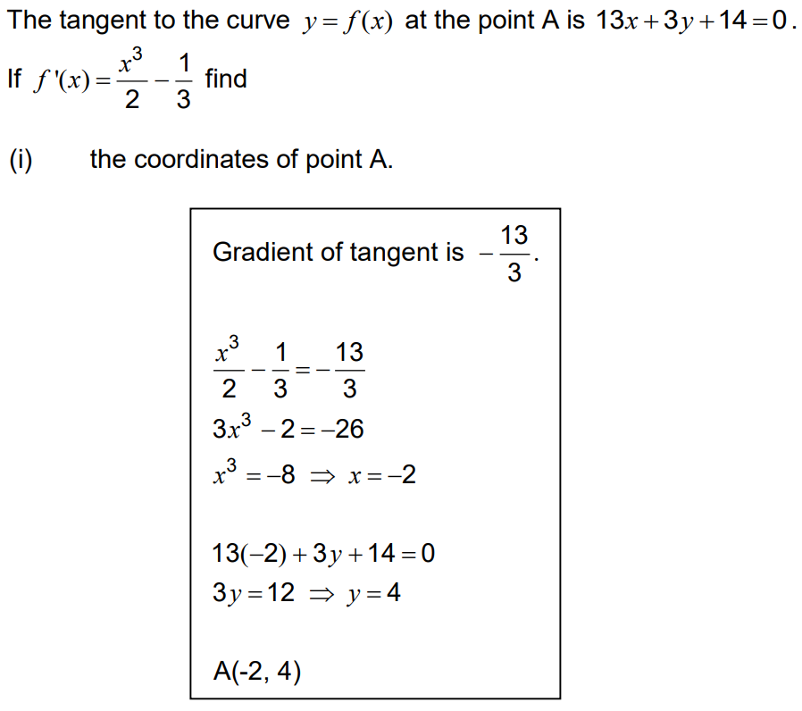

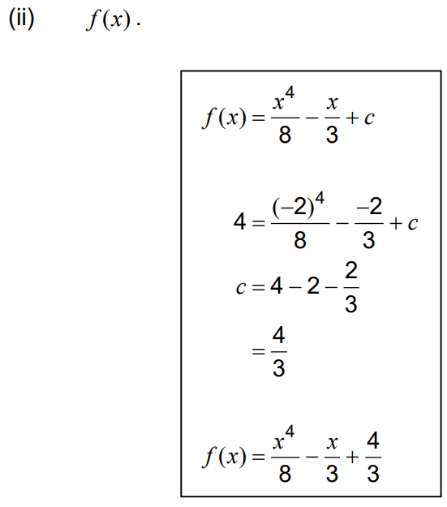

2015 B Calc-free:
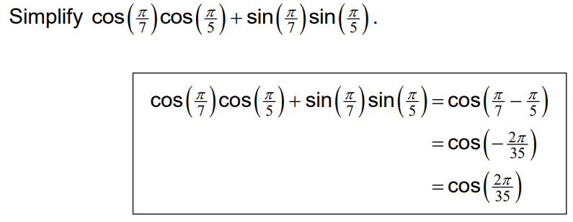

2015 B Calc-assumed:
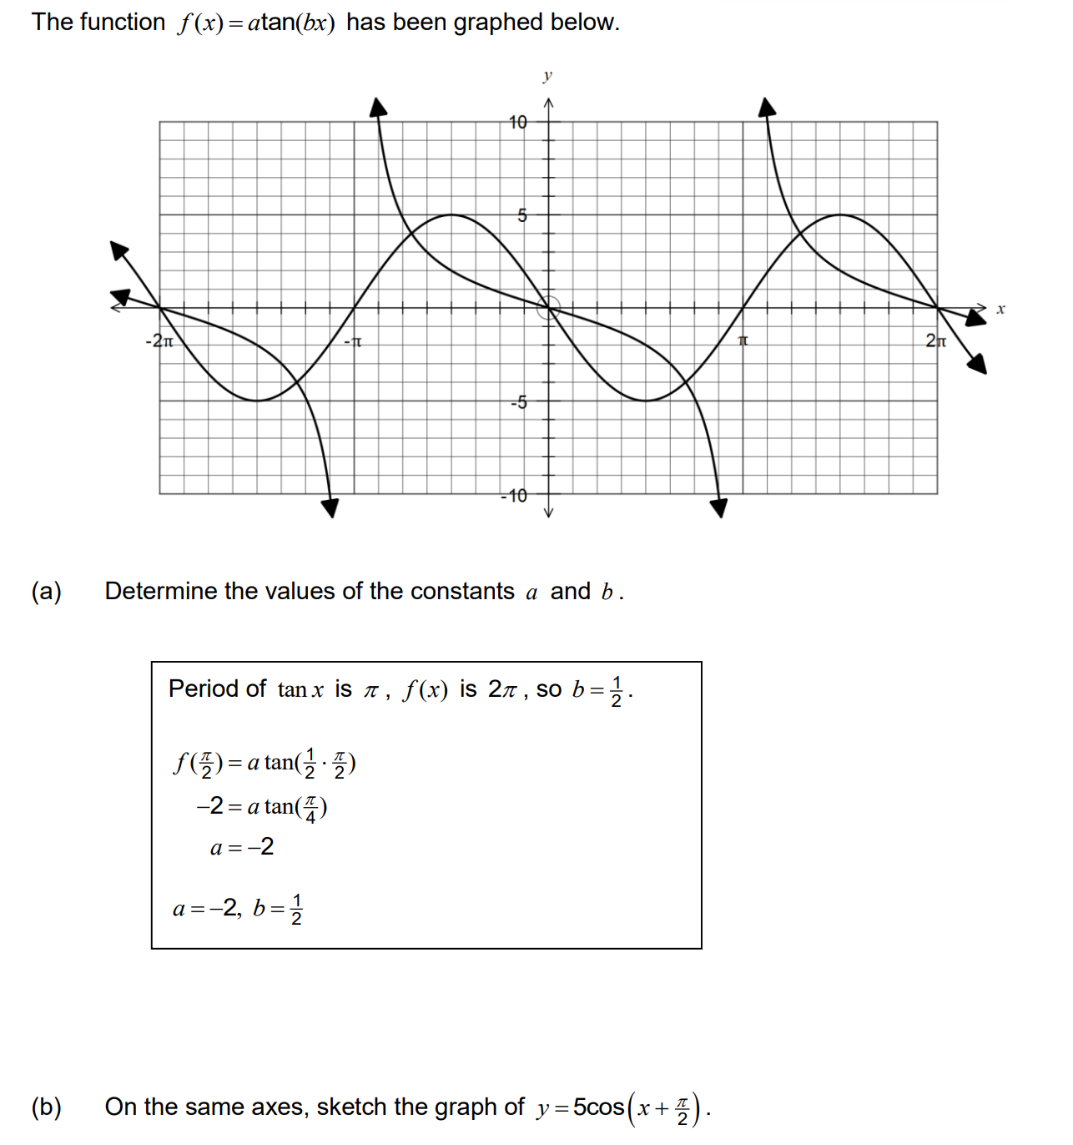
2015 B Calc-assumed:
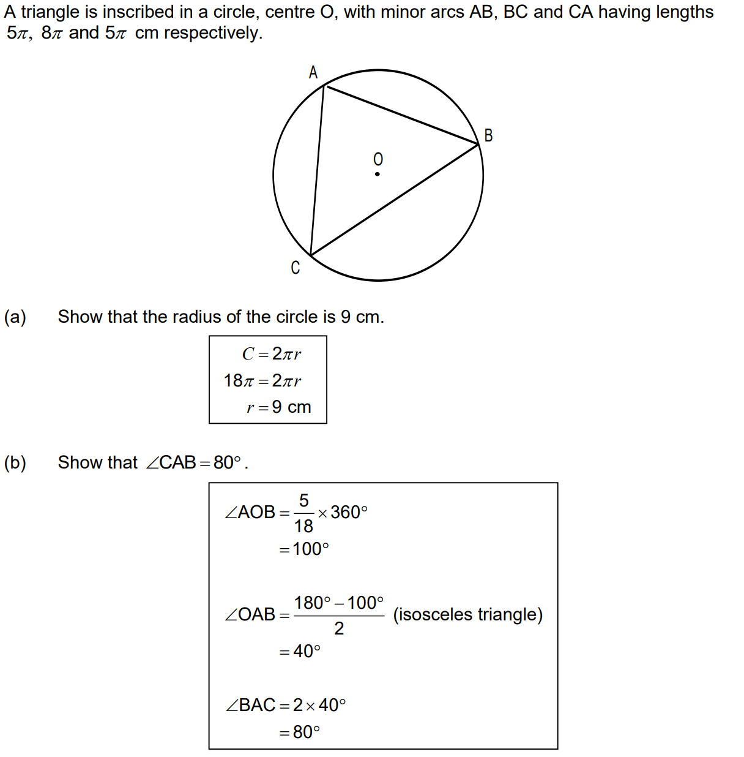
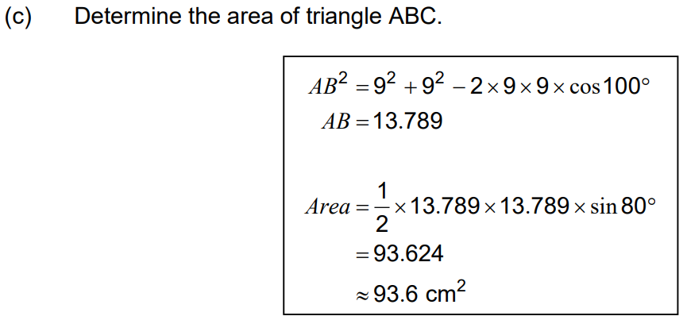
2016 B Calc-assumed:
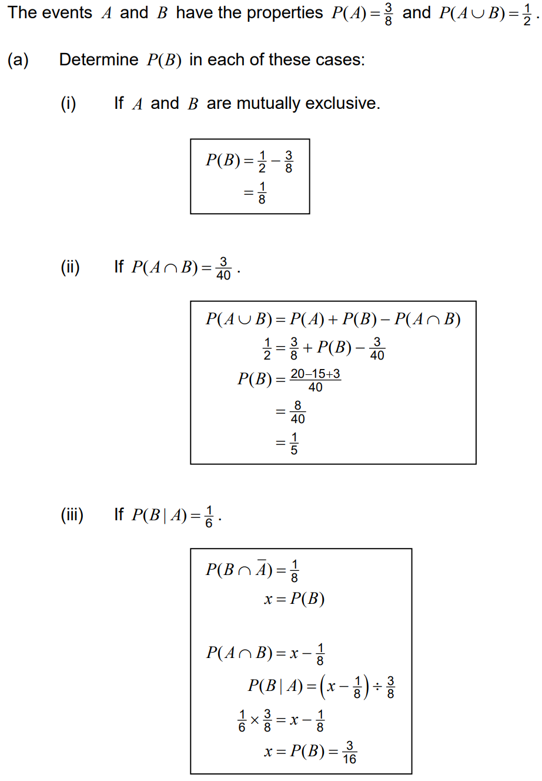
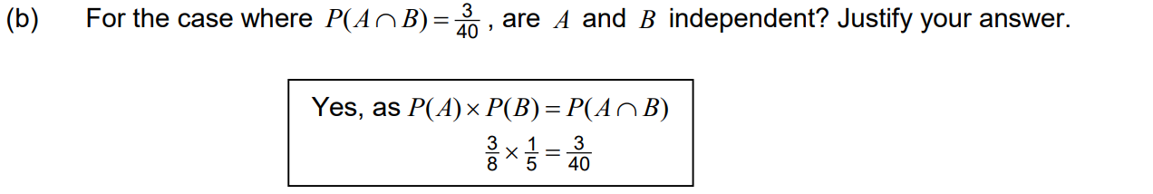

2015 C Calc-assumed:
A store accepts credit card payments from customers using American Express, Mastercard or VISA cards. Records indicate that 65% of customers use a credit card, and of these customers, 20% use American Express, 35% Mastercard and the rest VISA. Further analysis shows that the male to female ratio for users of each type of card is 5:3 for American Express, 2:3 for Mastercard and 3:2 for VISA.

a) Calculate the probability that a randomly selected customer from the records will be a female who uses an American Express credit card.

b) Given that a randomly selected customer used a credit card, what is the probability that they are male.

c) What is the probability that a randomly selected female customer who used a credit card used a VISA card.

2015 C Calc-assumed:
Two independent events A and B are such that P(A ∩ B) = 0.2 and P(B’) = 0.6.
a) Calculate:
i) P(A)

ii) P(A ∪ B)

iii) P(B’ | A’ ∪ B’)

b) A third event, C, is complementary with event A. What is the maximum possible value of P(C ∪ B)?

